Practical no. 16
Name :- Danish Altaf Solkar Enrolment no. :-24111590805
Class :- CO3K – B Subject :- OOP
Aim :- Write programs to implement :- 1. Pointer to Object 2. ‘This’ pointer
Program :-
#include<iostream.h>
#include<conio.h>
class Book{
public:
char book_name[50];
char author_name[50];
int price;
void accept(){
cout<<"\nEnter Book Name :- ";
cin>>book_name;
cout<<"\nEnter Author Name :- ";
cin>>author_name;
cout<<"\nEnter Price :- ";
cin>>price;
}
void display(){
cout<<"\nBook Name :- "<<book_name;
cout<<"\nAuthor Name :- "<<author_name;
cout<<"\nPrice :- "<<price;
}
};
void main(){
Book b,*p;
clrscr();
p=&b;
cout<<"\nEnter Book details :- ";
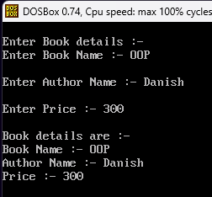
p->accept();
cout<<"\nBook details are :- ";
p->display();
getch();
}
Output :-

Program :-
#include<iostream.h>
#include<conio.h>
class Box{
public:
int height;
int width;
int breadth;
void accept(){
cout<<"\nEnter the height :- ";
cin>>height;
cout<<"\nEnter the width :- ";
cin>>width;
cout<<"\nEnter the breadth :- ";
cin>>breadth;
}
void display(){
int area,volume;
area=2*(height+width+breadth);
cout<<"\nArea of Box :- "<<area;
volume=height*width*breadth;
cout<<"\nVolume of Box :- "<<volume;
}
};
void main(){
Box b;
clrscr();
b.accept();
b.display();
getch();
}
Output :-
